Goal 1: Compare 2 files (old and new version of the data). Please see attached them.

Data

File 1 (old version of the data) called 1MC03-SCJ-IM-REP-SS01_SL03-242400_P07_Data

It contains,

* 74 columns with different names in the first tab.
* 110 rows including header in the first tab.
* 3 tabs with different names.

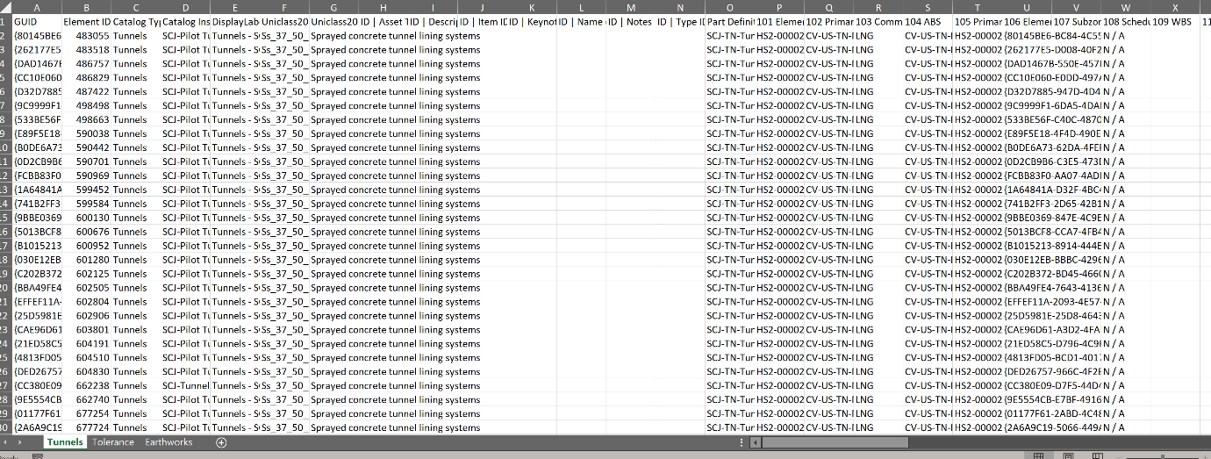

tabs

columns

File 2 (new version of the data) called 1MC03-SCJ-IM-REP-SS01_SL03-242400_P08_Data

It contains,

* 74 columns with different names in the first tab.
* 130 rows including header in the first tab.
* 3 tabs with different names.



tabs

columns

In this case, both Files have the same number and names of columns and tabs however sometimes both Files have different number/names of columns, tabs, and number of rows.

Result to obtain

* Add all the data from both Files (File 1 and File 2) in one File called ‘Comparison’ and one tab.
* Add a column called ‘Row from File’ to mention from which file was obtained the row.
* Add a column called ‘Identify GUID’ to mention if the GUID is GUID new, GUID old, or GUID same after doing a comparison considering the ‘GUID’ column. That column will always appear in all Files.
* Do a comparison of the rest of the columns considering if the GUID is GUID same (some of data in the rest columns may have changed – highlighted in yellow those changes), GUID old (not data should have changed) and GUID new (they should have completely new information).

Goal 2: Filter information from File 3. Please see attached it.

Data

File 3 called 1MC03-SCJ-IM-REP-SS01_SL03-290400_P11_Data

Not always the Files have the same number/names of columns, tabs and number of rows.

Result to obtain

* Add all the tabs in a new File called ‘Filter’ and in a one tab called ‘All Design Packages’
* Filter by header column and generate with the result one tab per ‘115 Design Package’ column. In this case, File 3 has 4 Design Packages: ECS-MW, ECS-CC, ECS-CW, Blanks. Called each tab, the same as the Design Packages.

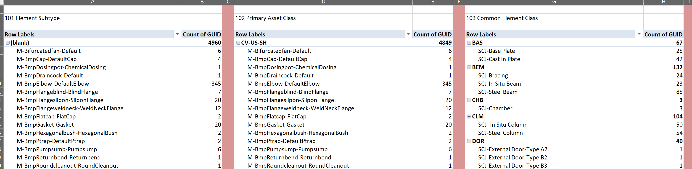

* Note that once this information is obtained, a comparison will be made with other files to verify if the information in File 3 is correct or needs to be modified. In some cases, the comparison is not direct. It should be selected depending on any other factors.
* Leading and trailing spaces. Check is any data has blank space at the beginning or end of each word. Add a tab called ‘Spaces’ with the findings in the ‘Filter’ File.

Goal 3: Search/Comparison between File 4 and File 5. Please see attached them.

Data

File 4 called 1MC03-SCJ-IM-REP-SS01_SL03-040400_P13_Data

File 5 called 1MC03-SCJ-IM-SCH-S000-990010

Result to obtain

* From File 4, obtain a list from ‘Catalog Instance’ column with their ‘Uniclass2015’, ‘Uniclass2015description’ and ‘103 Common Element Class’ of all tabs.
* Add in a new File called ‘Search’ and in a one tab called ‘Comparison’ that list.
* Add a column called ‘Row from File’ to mention from which file was obtained the row.
* Search the ‘Catalog Instance’ column in all tabs of the File 5 and if that value is found
* Extract from File 5, the ‘Catalog Item Name’ assign it under ‘Catalog Instance’ column, its ‘Uniclass Code’ assign it under ‘Uniclass2015’ column, ‘Uniclass Description’ assign it under ‘Uniclass2015description’ column, ‘Common Element Class’ assign it under ‘103 Common Element Class’, ‘LoGD at Final Submission’, ‘LoD Notes’ and ‘Notes’ columns.
* Add in ‘Row from File’ column from which file was obtained the row.
* Do a comparison considering the ‘Catalog Instance’ column and highlighted in yellow the changes.